**Execute an Azure Function with Triggers**

Create a Function App: a. Go to the Azure Portal. b. Select Create a resource, Compute > Function App. i. Resource Group: Select your Resource Group ii. Function App name: Unique Name iii. Publish: Code iv. Runtime Stack: PowerShell Core v. Region: Any

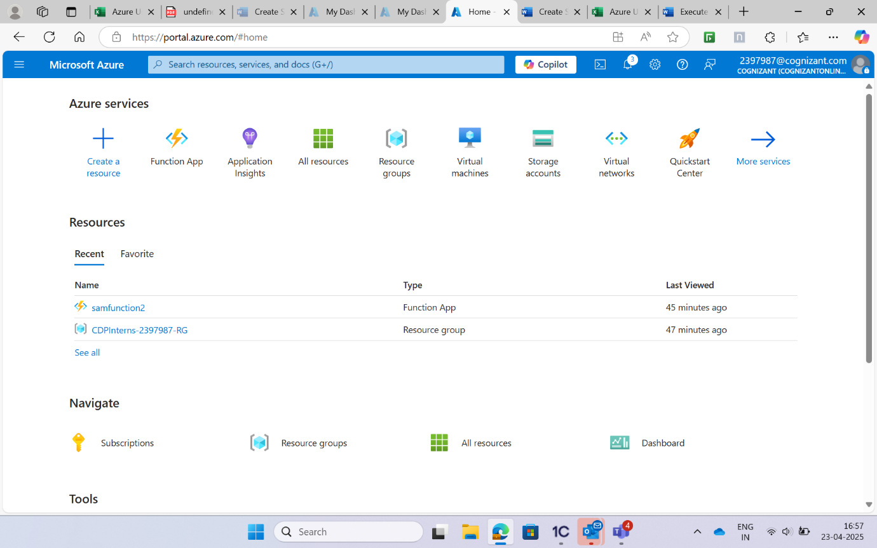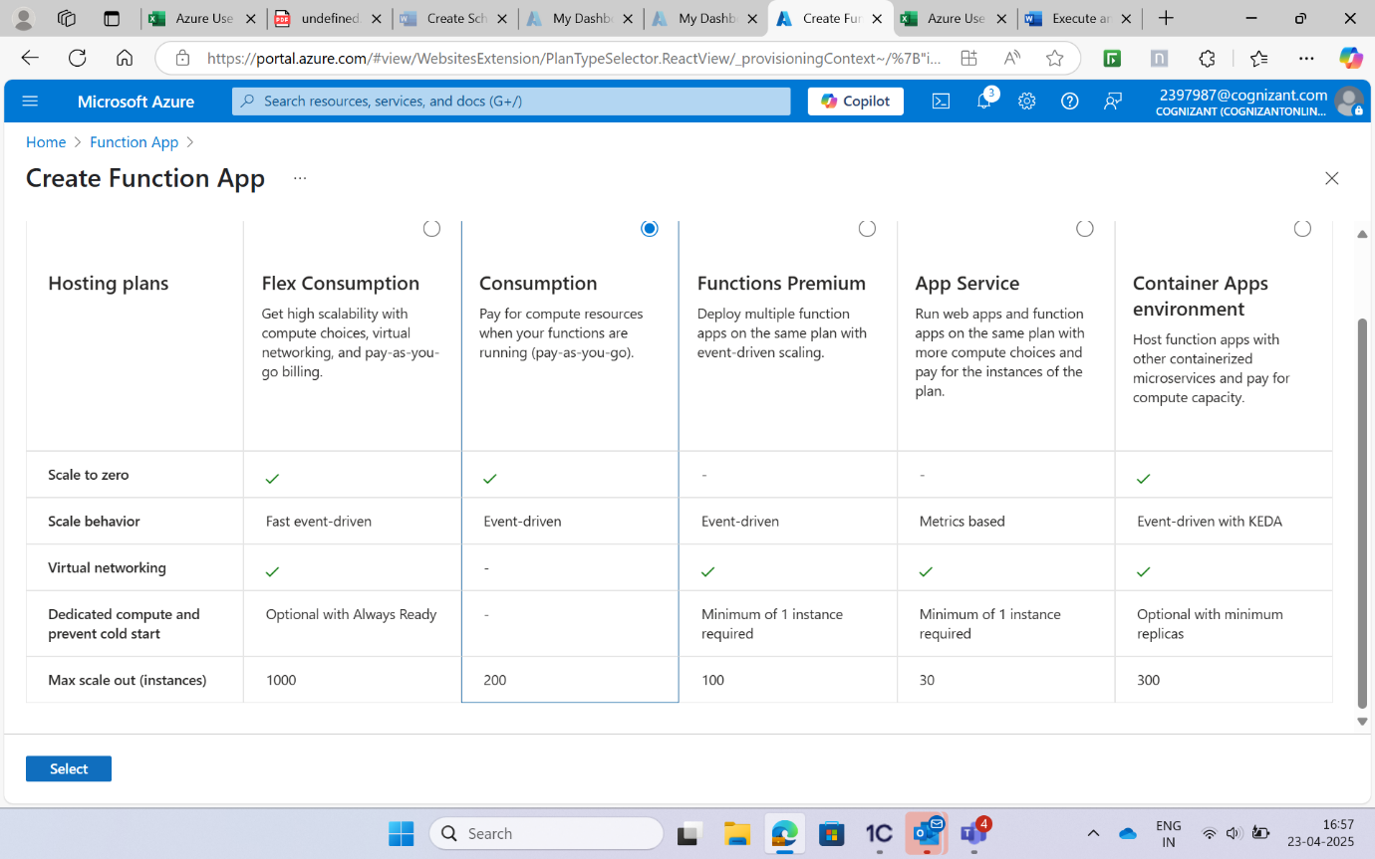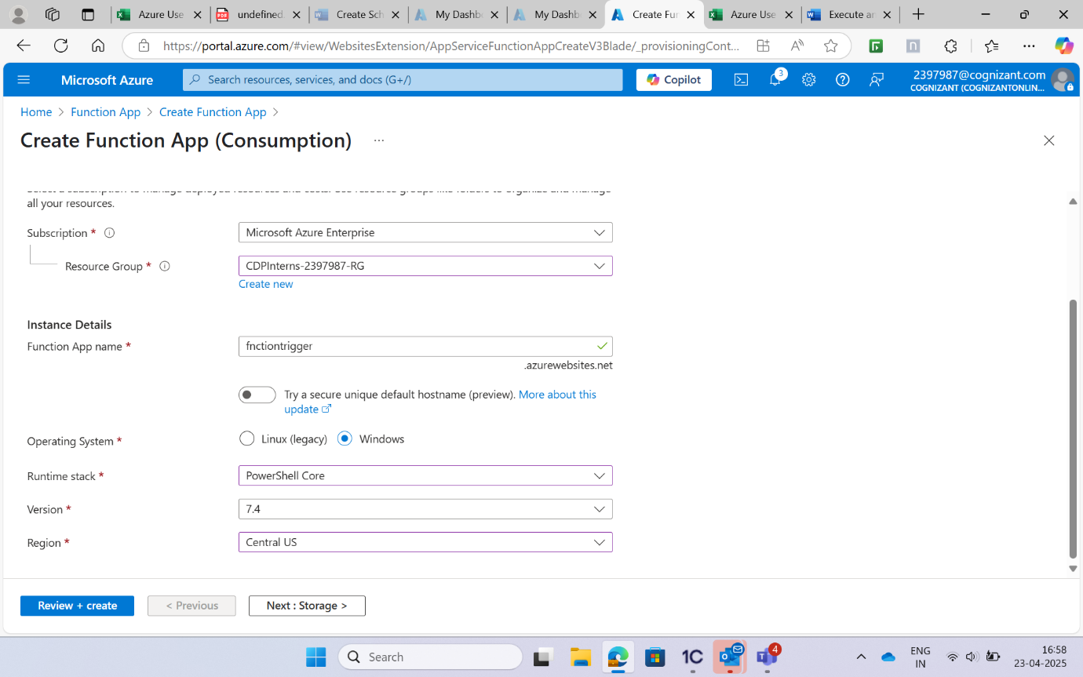a. Go to the Function App created by you. b. Go to the Functions blade and click on Add. c. Select Timer Trigger from the templates.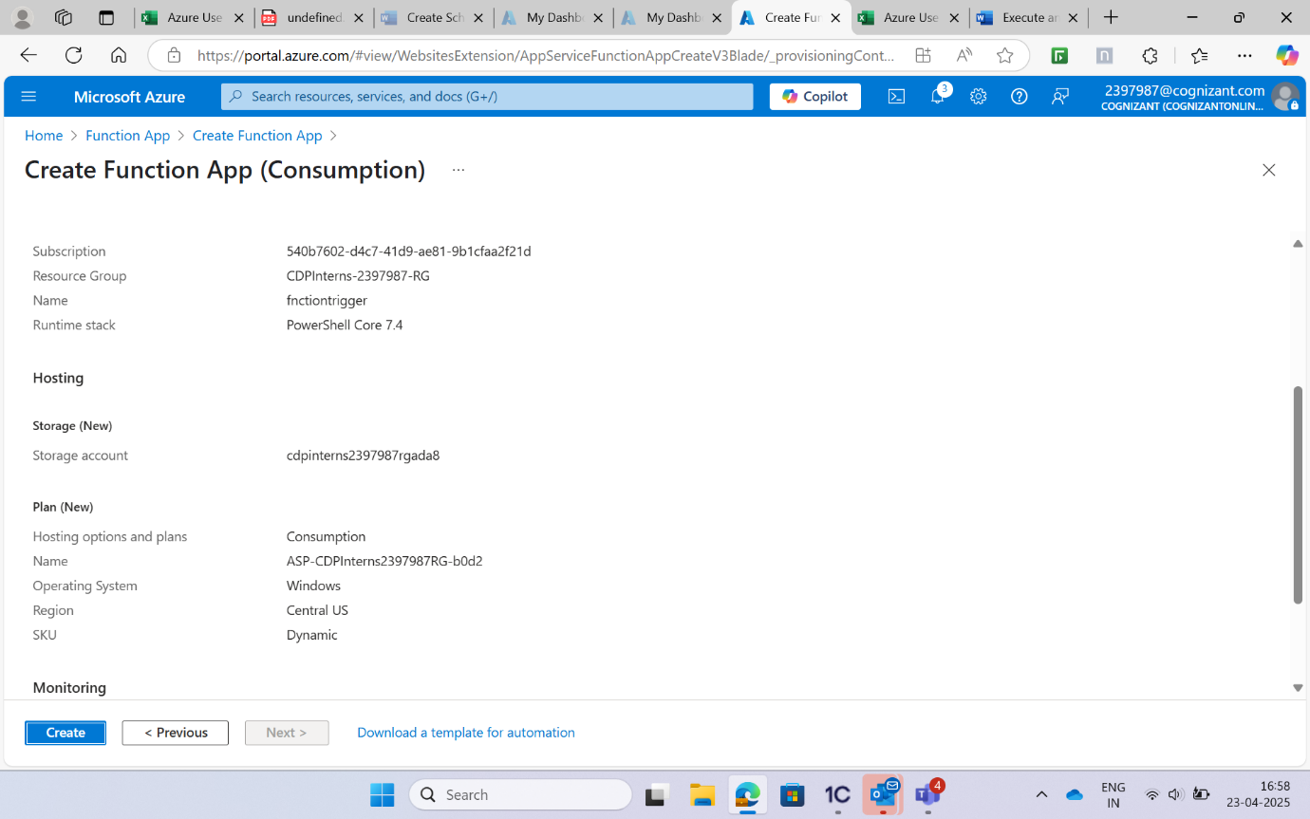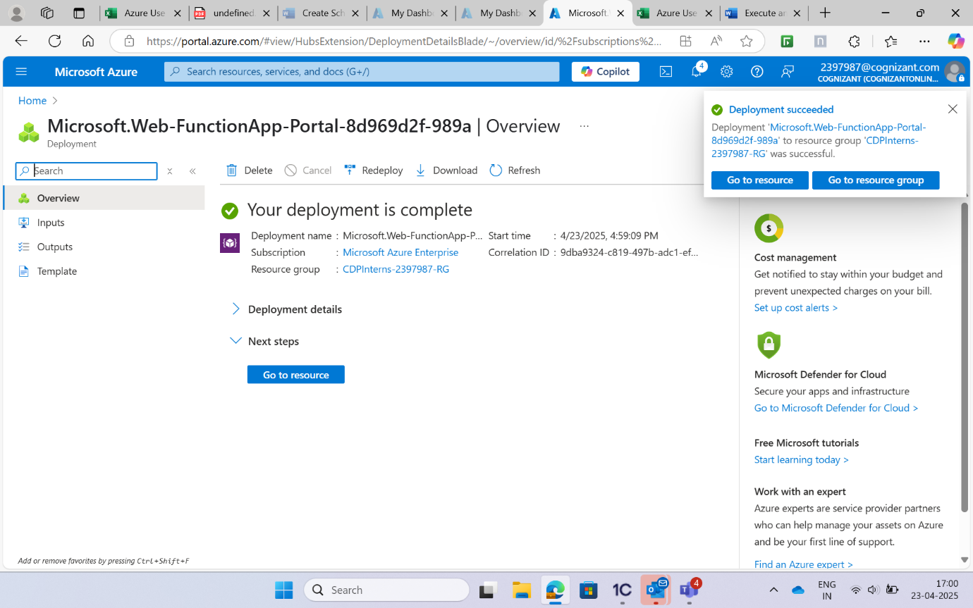 Configure the timer trigger: